React useRef Hook

The useRef Hook allows you to persist values between renders.

It can be used to store a mutable value that does not cause a re-render when updated.

It can be used to access a DOM element directly.

**useRef() only returns one item. It returns an Object called current.**

**Does Not Cause Re-renders**

If we tried to count how many times our application renders using the useState Hook, we would be caught in an infinite loop since this Hook itself causes a re-render.

To avoid this, we can use the useRef Hook.

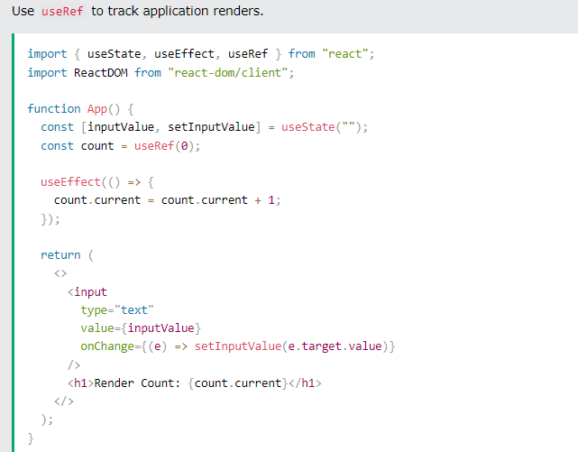

**Accessing DOM Elements**

In general, we want to let React handle all DOM manipulation.

But there are some instances where useRef can be used without causing issues.

In React, we can add a ref attribute to an element to access it directly in the DOM.

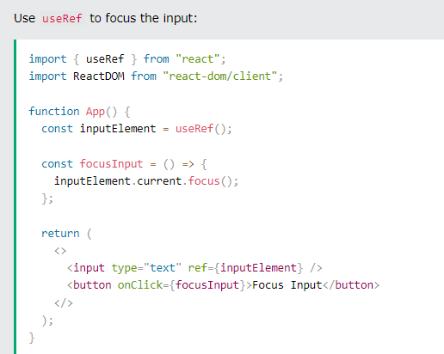

**Tracking State Changes**

The useRef Hook can also be used to keep track of previous state values.

This is because we are able to persist useRef values between renders.

